ECOLOGICAL PYRAMIDS

Ecological pyramids can provide a model that can be used to describe various aspects of an ecosystem. They can show the flow of energy, the recycling of matter through an ecosystem or the numbers of organisms and the relationships between them.

The size of the box indicates the number or amount of the feature being considered.

Energy pyramids

An energy pyramid for a food chain shows a larger box at the bottom and smaller boxes as you move up the food chain. Energy pyramids always have this basic shape, because only some of the energy captured by producers is converted into chemical energy.

Of the energy captured, only about 10 per cent is passed on through each feeding level, with about 90 per cent of the energy being transferred to the environment as
heat or waste.

This decrease in energy along the food chain is one reason that the numbers of levels in food chains are limited. There is also a limit to the number of organisms that can exist at each level of the food chain.

Energy pyramids show that, as you move up the food chain or web, there is less food energy to go around and therefore fewer of each type of organism.

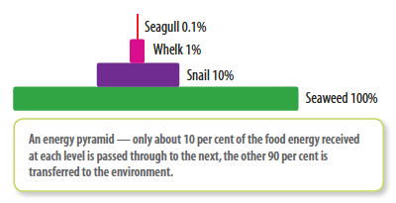

Pyramids of numbers and biomass

A pyramid of numbers indicates the population or numbers of organisms at each trophic level in the food chain.
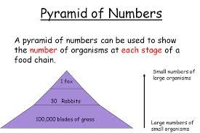

A pyramid of biomass shows the dry mass of the organisms at each trophic level.
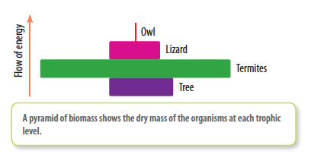
These pyramids can appear as different shapes due to reproduction rates or mass
differences between the organisms.

